Transpiration in plants
What is it?
Transpiration is a process that involves loss of water vapour through the stomata of plants. Transpiration is thought to be a ’necessary cost or evil’ to allow the plant to absorb water from the soil. It is an inevitable process.
Why does it happen?
Transpiration is important in plants for three major reasons:
1. Cooling of the plant: the loss of water vapour from the plant cools down the plant when the weather is very hot.
2. The transpirational pull: when the plant loses water through transpiration from the leaves, water and mineral salts from the stem and roots moves, or is ‘pulled’, upwards into the leaves. Water and is therefore taken up from the soil by osmosis and finally exits the plants through the stomata.
3. Plant structure: young plants or plants without woody stems require water for structural support. Transpiration helps maintain the turgidity in plants.
Plant Transport system – how it is involved in Photosynthesis and Transpiration
There are two types of tubes that transport food and water inside plants.
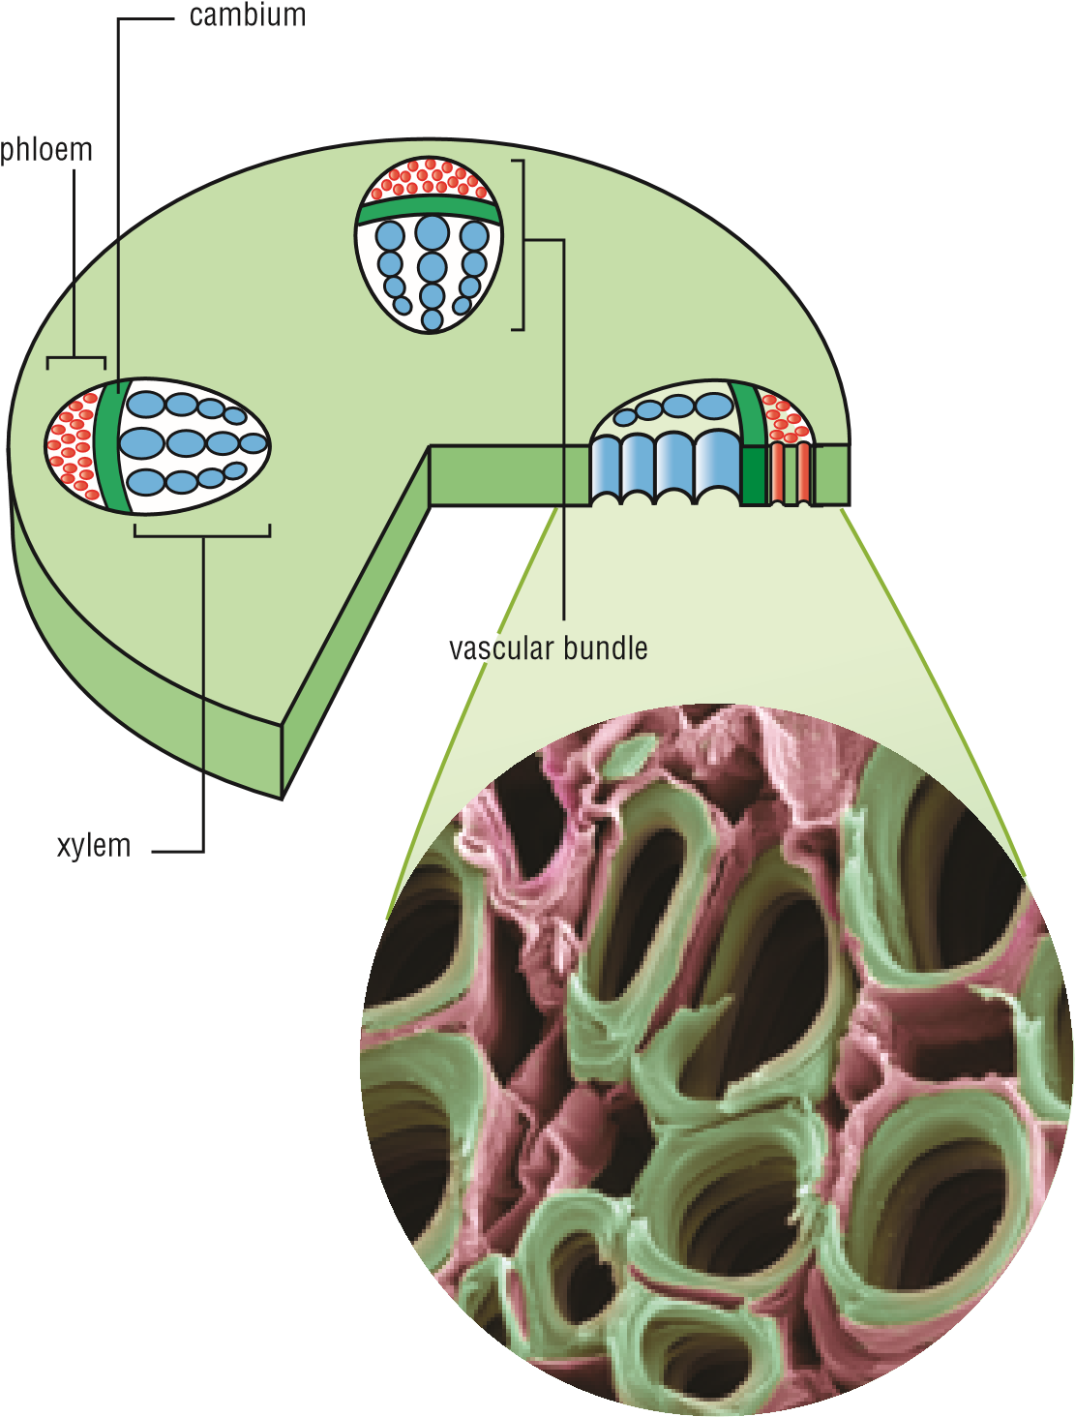
- Xylem tubes carry water and minerals (from the soil, up into the stems and leaves. Xylem tubes are made of dead cells strengthened with a woody substance. Unlike animals, a plant does not have a heart to pump liquid through its tubes. Instead, water is pushed upwards by two processes. The first is by pressure in the roots pushes water up. The second is by evaporation of water from the leaves sucking the water upwards. Movement of water is one way - always upwards through the trunk and outwards from the trunk. Therefore, Xylem tubes supply the water for photosynthesis.
8.1.7 Xylem and phloem tubes are grouped together in vascular bundles, separated by a layer of cambium cells which are able to become either new xylem or new phloem cells, whichever is required.

- Phloem tubes are made from living cells. Their function is to transport the glucose that is produced by photosynthesis in the leaves to the stem and roots. Some plants store glucose while others convert it into starch which is then stored. Therefore, Phloem tubes distribute the glucose made from photosynthesis.
Sweet!
Lettuce and cabbage store glucose in their leaves.
Celery stores glucose in its stem and carrot plants
store it in their fleshy root (carrot). Plants that store
food as starch are not as sweet as plants that store
food as glucose, which explains why potatoes are
not as sweet as carrots. A green banana contains
starch but this changes into glucose as it ripens—
hence ripe bananas are sweeter than green ones.

